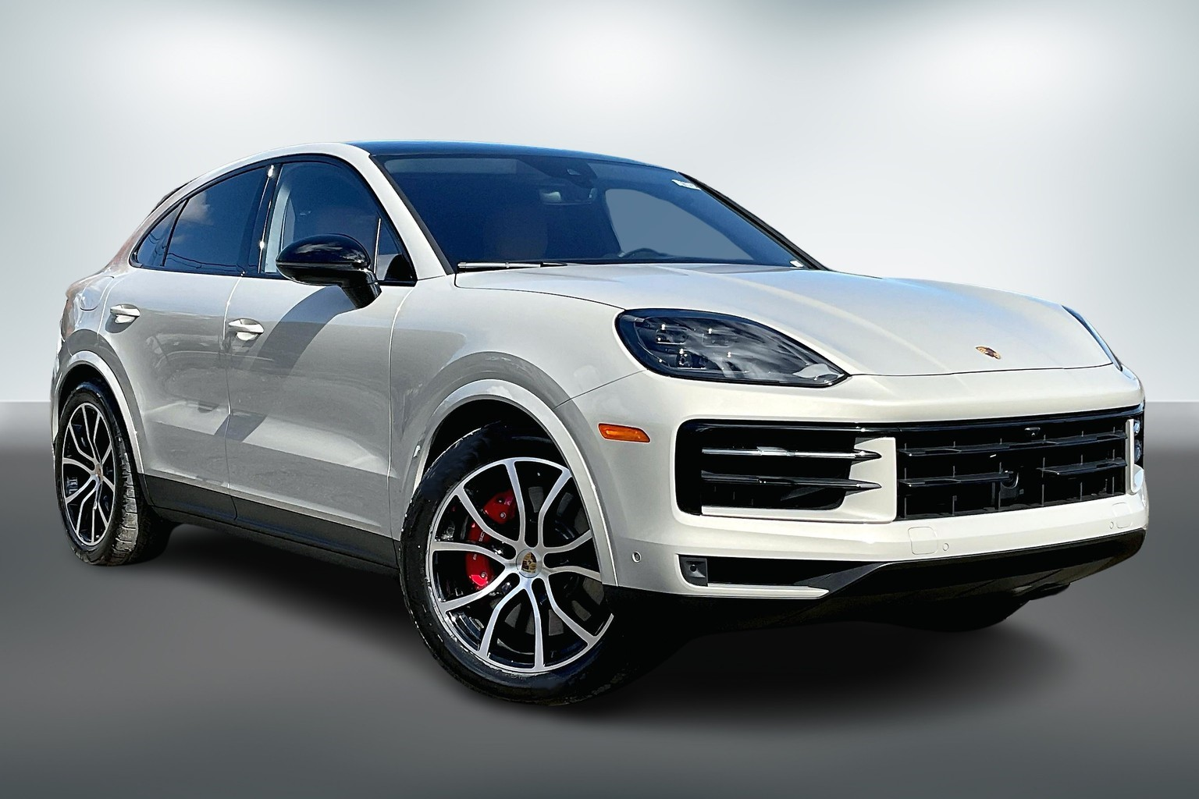



# **Porsche**

Porsche air suspension systems provide a comfortable and soft ride on the road. When there is an air leak in your Porsche air suspension system, it can cause the air suspension compressor or other electrical components to overwork and burn out. When Porsche air struts or air spring bags go out, your Porsche is nearly impossible to drive. BAVARIA CENTER provides many solutions for your air suspension repair. We offer many Aftermarket Parts, New or Remanufactured, including Air Struts, Air Spring Bags, Compressors, Air Supply Solenoid Valve Blocks and more. Our friendly staff is available to assist you and your satisfaction is our guarantee.